# Dairy Delights

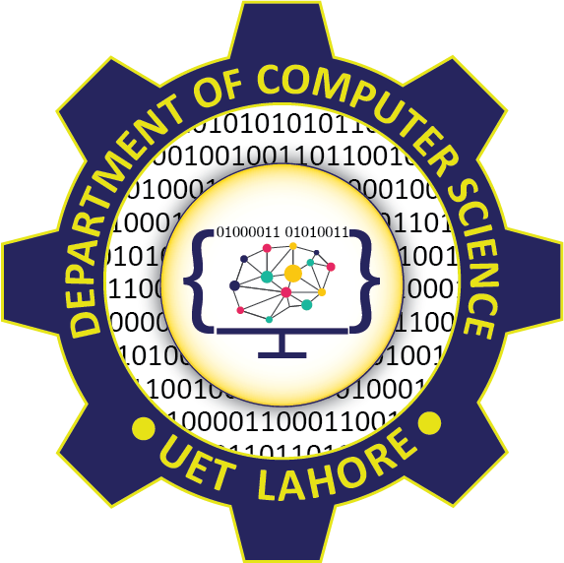

Session: 2021 – 2024

**Submitted by:**

## Abu Tayyab 2023-CS-54

**Supervised by:**

## Prof. Maida Shahid

Department of Computer Science

**University of Engineering and Technology**

**Lahore Pakistan**

# Dairy Delights